Homework Assignment 1

Name: Linqi Xiao NetID: lx130

## Problem 1 (Practice the computation of KNN)

When K = 1, classified label is ‘A’

When K = 2, classified label is ‘A’

When K = 3, classified label is ‘A’

## Problem 2 (KNN for simple data)

K = 1

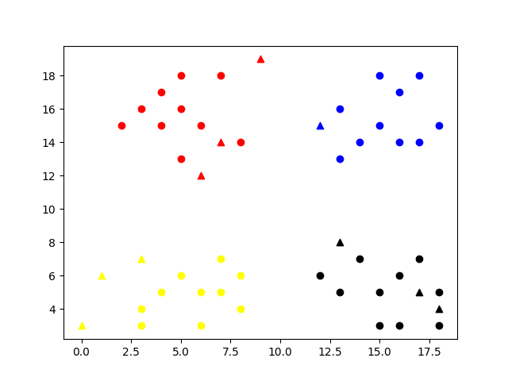

K = 5

K = 10

## Problem 3 (KNN for handwriting digit recognition)

I choose 20 testing images and train them on all 60000 training datasets, the accuracy is 0.95

